1-hypertuning gridsearch

Study questions
Epochs: what is the upside, what is the downside of increasing epochs? Do you need more epochs to find out which configuration is best? When do you need that, when not?
The advantage of more epochs is that accuracy usually increases. However, too many epochs can lead to overfitting, where the model learns patterns in the data instead of just training on it. We can use early stopping. If we see only a very small improvement in accuracy, we can avoid overfitting and reduce hardware usage.
What is the upside of using factors of 2 for hypertuning? What is the downside?
You can easily scale between numbers without thinking too much. Sizes like 32 and 64 often work better for hardware than other “weird” numbers. A downside is that the best numbers might be missed, for example, 46 could have been optimal, but we would never know because we only used factors of 2.

Short Report
Hypothesis: I hypothesize that increasing the number of units and epochs will generally improve model accuracy up to a point, while batch size will have a moderate effect. I expect the choice of optimizer to influence convergence speed and stability but not drastically change the final accuracy.
Hyperparameter tested:
units1 | units2 | epochs | batchsize | lr | optimizer | Accuracy
256 | 256 | 5 | 32 | 0.001 | SGD | 0.5622
256 | 128 | 5 | 64 | 0.0001 | Adam | 0.871
128 | 128 | 10 | 32 | 0.001 | Adam | 0.8763
128 | 64 | 10 | 64 | 0.0001 | SGD | 0.6682
64 | 64 | 5 | 32 | 0.001 | SGD | 0.5068
64 | 128 | 10 | 64 | 0.0001 | Adam | 0.8797
256 | 64 | 5 | 64 | 0.0001 | Adam | 0.8658
128 | 256 | 10 | 32 | 0.001 | SGD | 0,6837
64 | 256 | 5 | 64 | 0.0001 | Adam | 0.8697
256 | 128 | 10 | 32 | 0.001 | Adam | 0.8825

For the results I have chosen to separate the optimizers (SGD and Adam) to get a clear view of every little change made.

Optimizer SGD
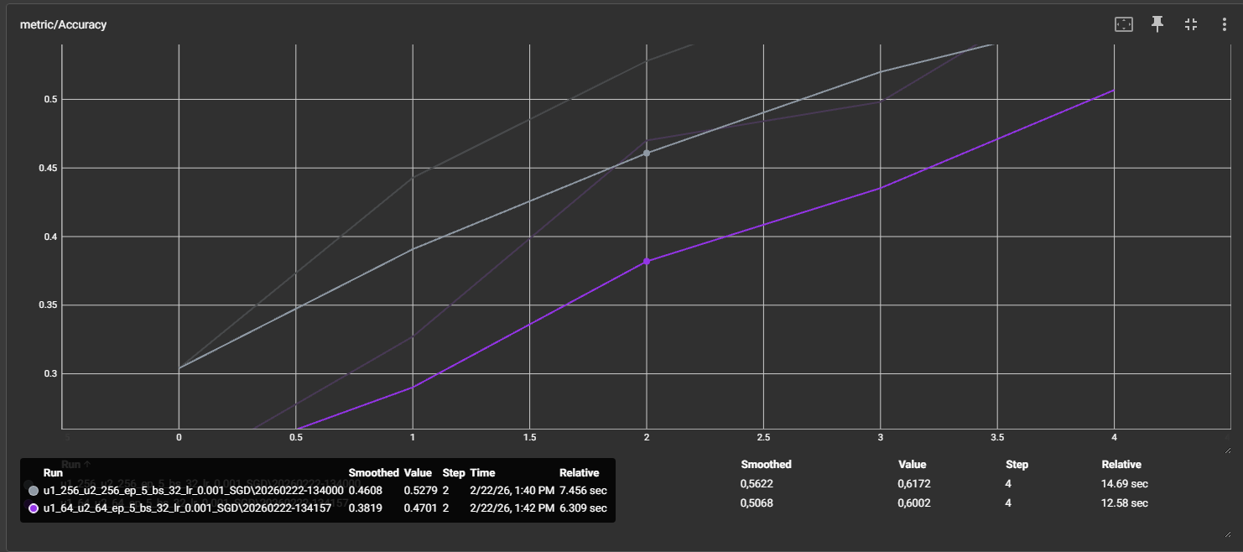
We can see that in the runs with 5 epochs, the same learning rate, and batch size, where only the units are changed, we see an increase in accuracy as the number of units is increased.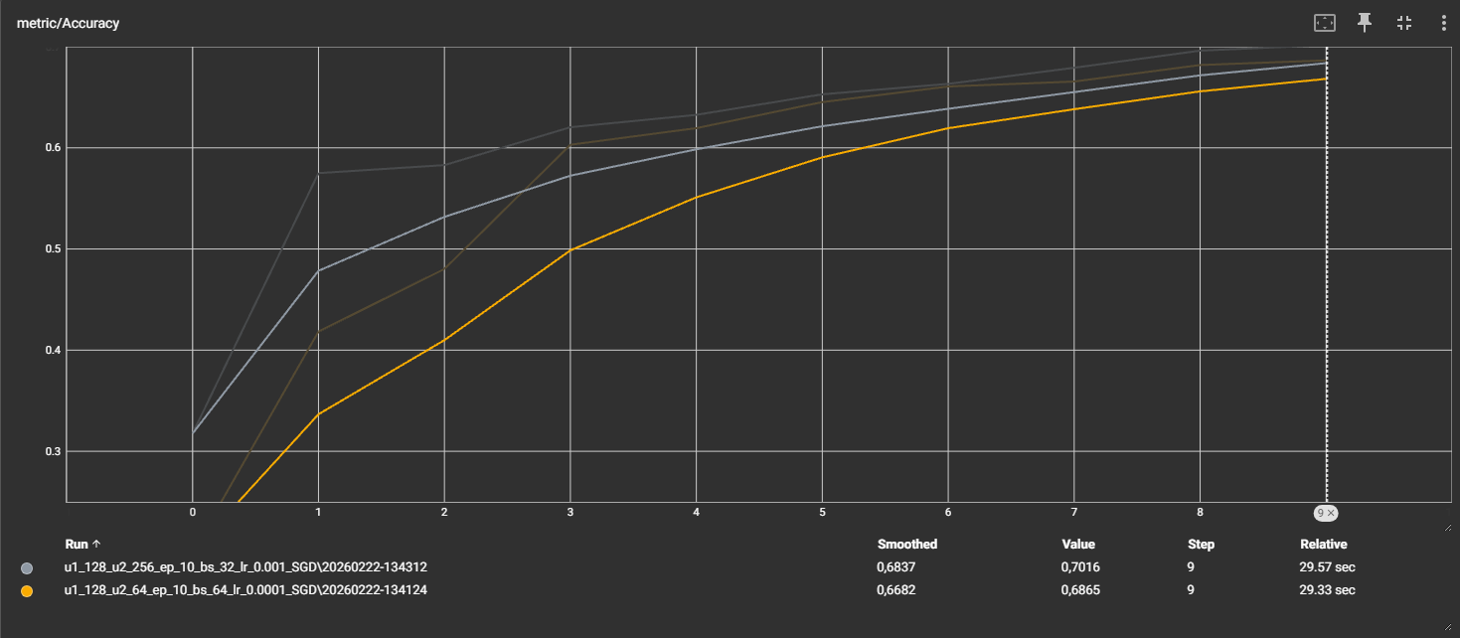
We can see that in the runs with 10 epochs, the same learning rate, and batch size, where only the units are changed, the accuracy increases as the number of units increases. However, when running more epochs, we notice that the effect of increasing units gradually diminishes over time, making it less relevant to the final accuracy.

Optimizer Adam
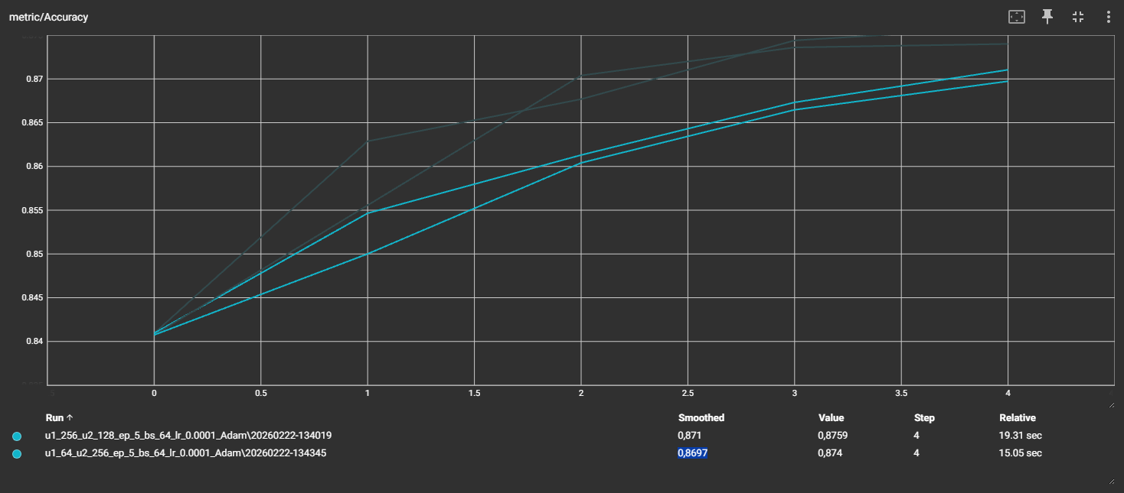
The runs with the Adam optimizer perform much better than the runs with SGD. Overall accuracy improves, and we see quite impressive accuracy percentages, even with only 5 epochs. We can also see that the number of units has less effect on the outcome, with unit1 having a more significant impact than unit2.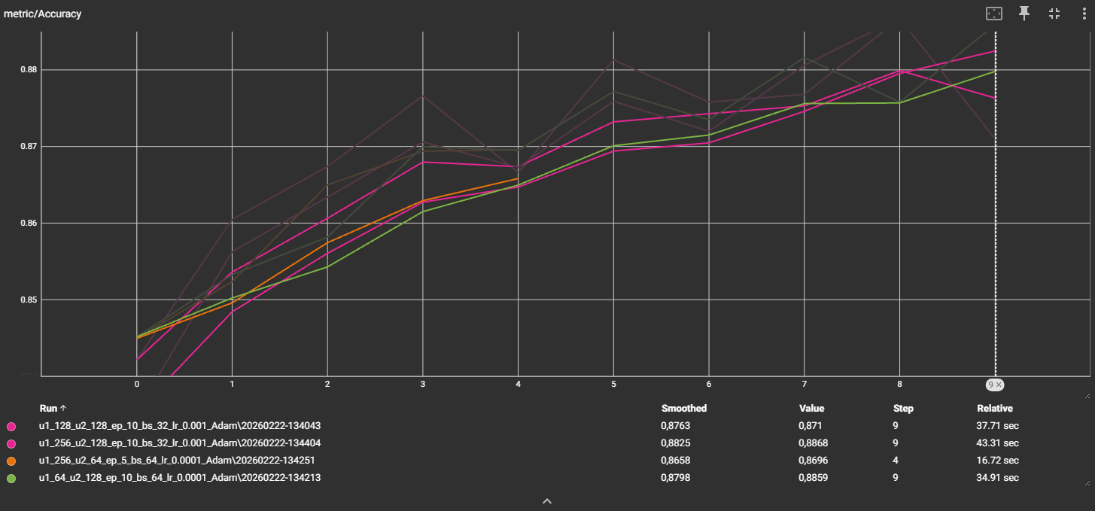
With 10 epochs, we see a lot of noise in the accuracy, changing rapidly. The overall accuracy is excellent and the highest we have observed so far. However, the loss/test behaves quite randomly.
Conclusion: The number of units has some effect depending on the optimizer, but as the number of epochs increases, the impact of adding more units decreases. Batch size did not have a strong effect on accuracy. Regarding optimizers, we observed that SGD performs poorly on this dataset, while Adam performs very well. However, SGD can achieve faster updates.

